**Week 7 Lab Report**

This document contains the template you will use to complete this assignment. Save the file by adding your last name to the filename (e.g. CIS246_W7_Lab_Report_EK_Smith.docx).

Follow the steps for this week’s lab. At various points in the instructions, you will be asked to answer a question or capture a screenshot to document your work – type your answers and place screenshots into this document, then submit this completed Lab Report to the appropriate weekly Dropbox.

***Screenshots***

**Task 2 Configure the networks file**

**Step 2: Append network**

|  |
| --- |
| **Clear the screen and use *cat* to display the contents of the /etc/networks file. Capture the Skillsoft desktop in the text box below.** |

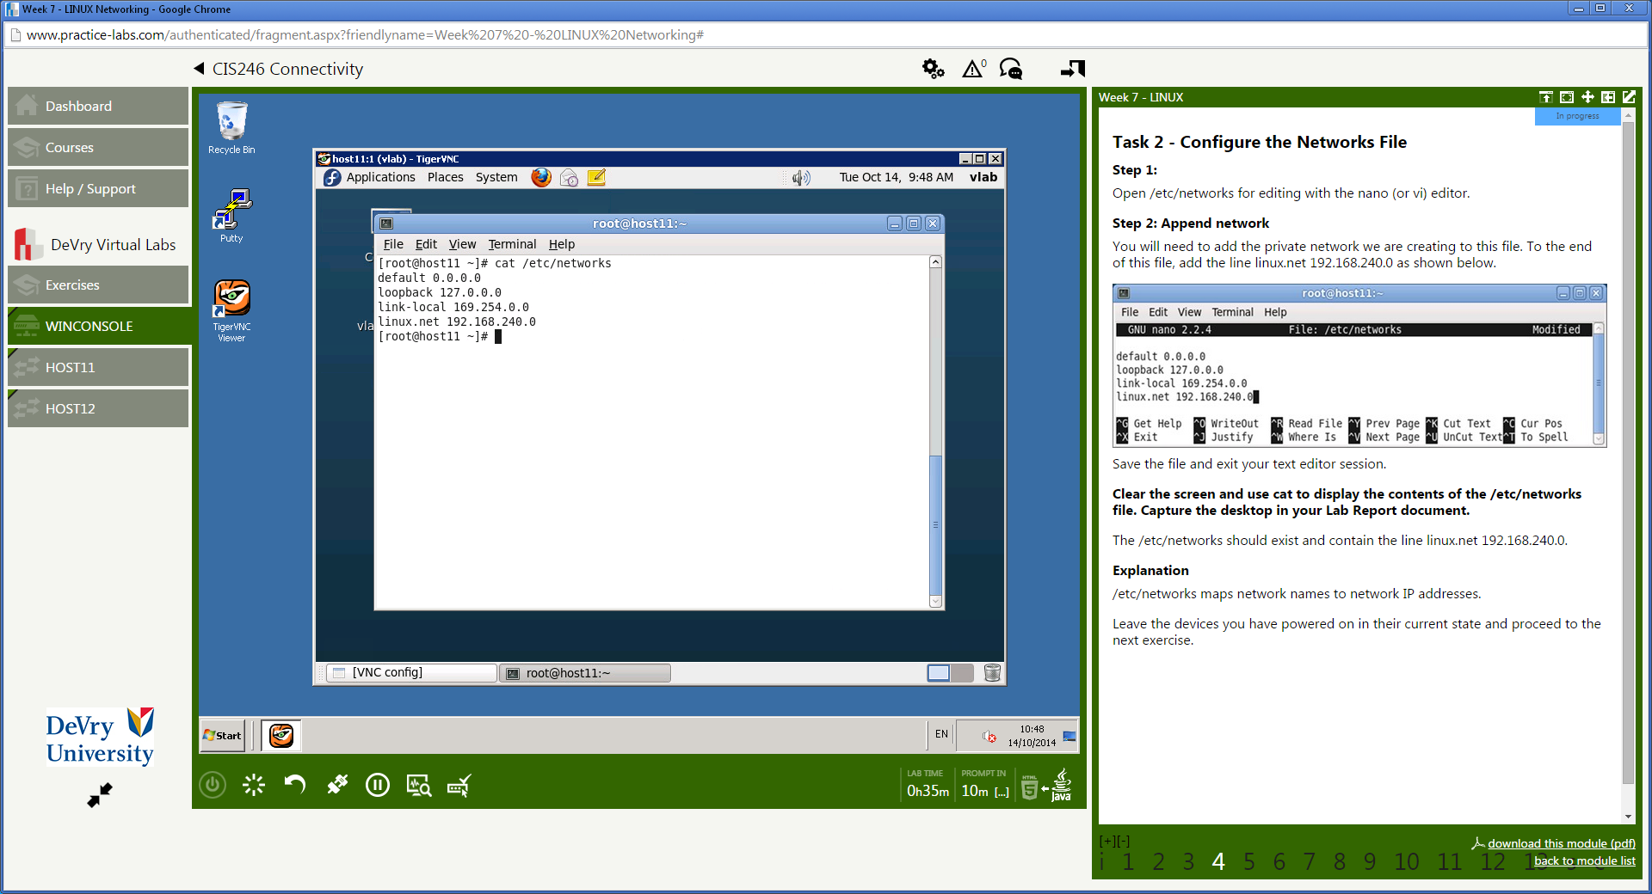

**Task 3 Configure the hostname and domain**

**Step 1: Add domain hostname to computer**

|  |
| --- |
| **Clear the screen and use *cat* to display the contents of the file in the /etc/sysconfig/network. Capture the Skillsoft desktop in the text box provided below.** |

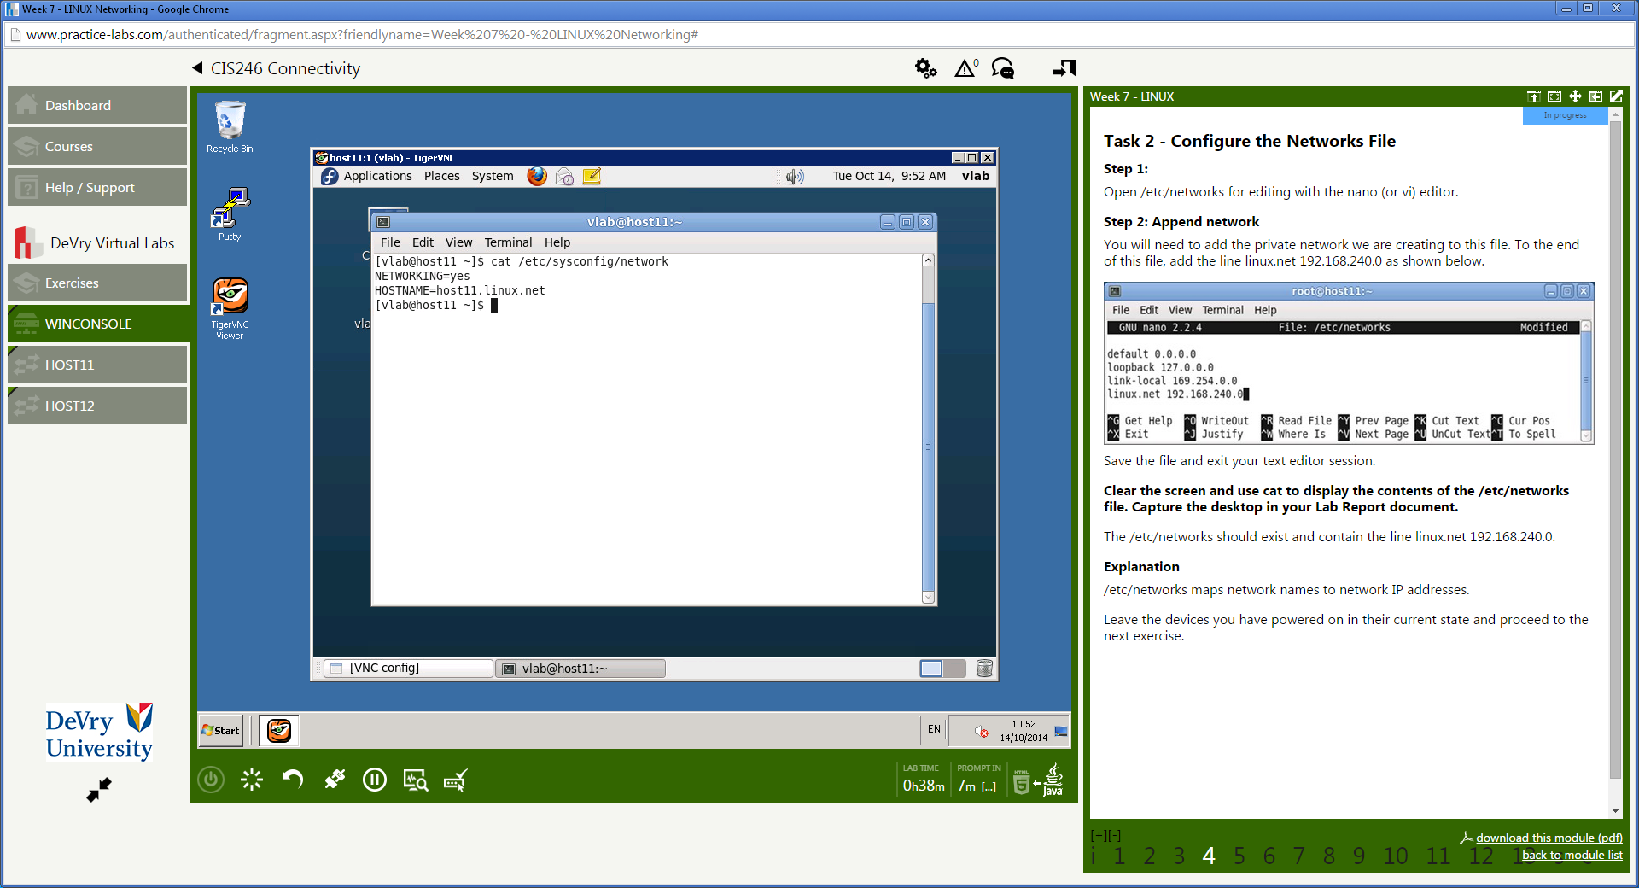

**Task 5 Configure the interface eth1 network configuration file**

**Step 1: Edit the eth1 network script**

|  |
| --- |
| **Clear the screen and use *cat* to display the contents of the ifcfg-eth1 file in the /etc/sysconfig/network-scripts directory. Capture the Skillsoft desktop in the box provided in your Lab Report document.** |

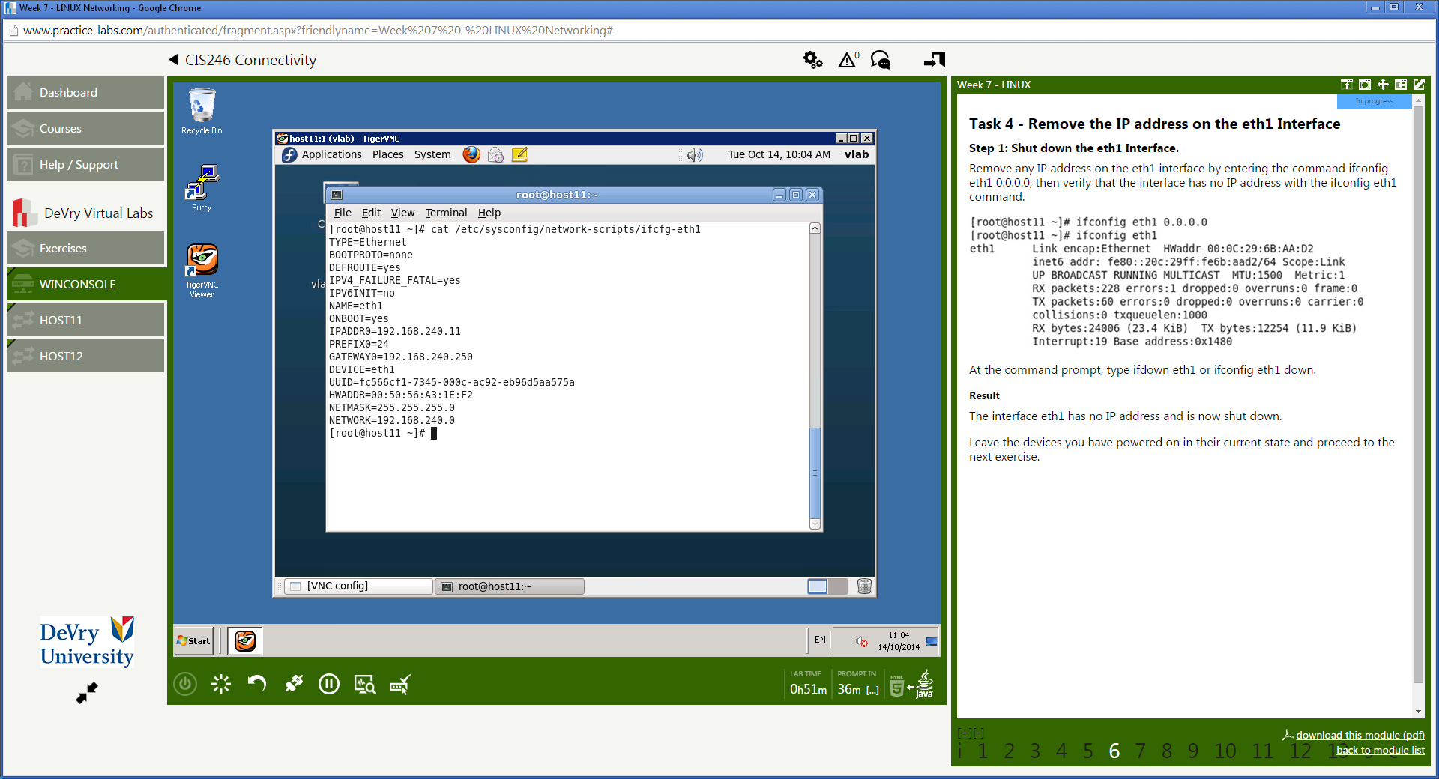

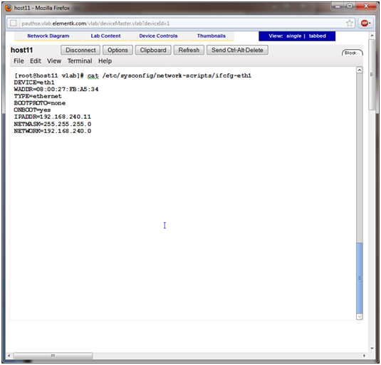

**Task 7 Configure the hosts file**

**Step 1: Update the /etc/hosts file**

|  |
| --- |
| **Clear the screen and use *cat* to display the contents of the /etc/hosts**  **file. Capture the Skillsoft desktop in the textbox provided below.** |

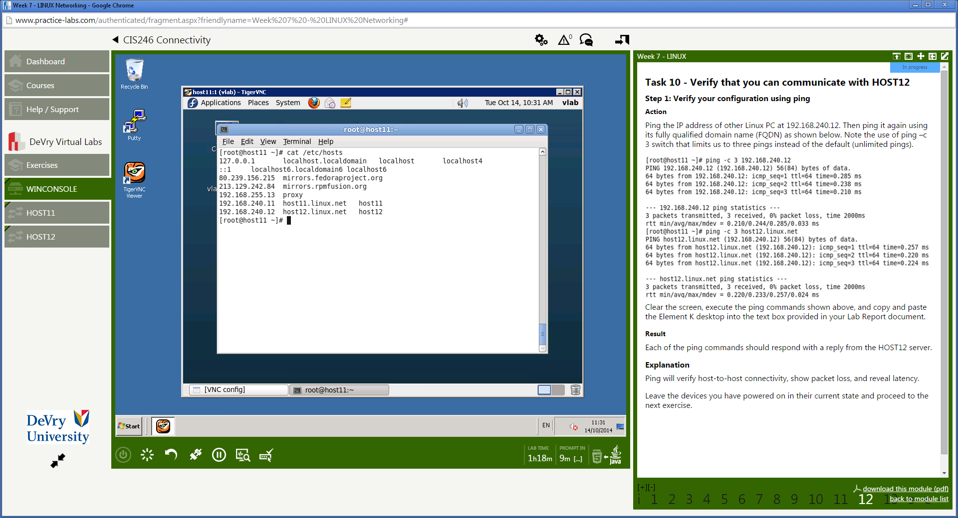

**Task 8 Configure the resolv.conf file**

**Step 1: Edit the resolv.conf file**

|  |
| --- |
| **Clear the screen and use *cat* to display the contents of /etc/resolv.conf**  **Capture the Skillsoft desktop in the text box provided below.** |

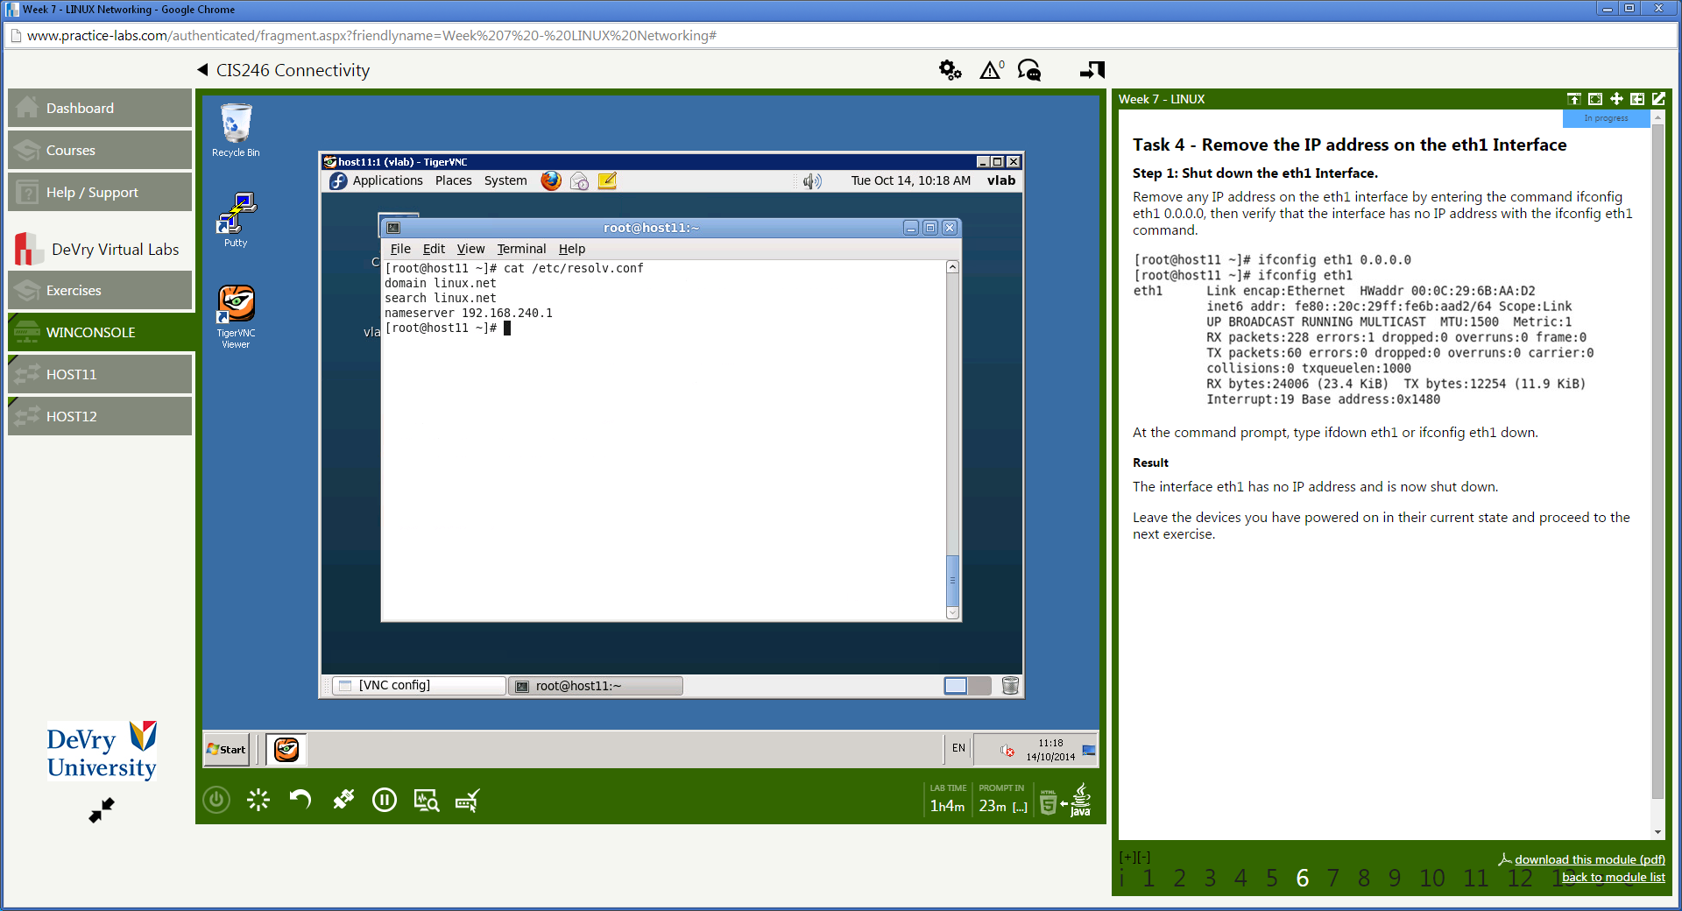

**Task 10 Verify that you can communicate with host12 and create output for Lab Report document**

**Step 1: Verify your configuration using *ping***

|  |
| --- |
| **Clear the screen and execute the *ping* commands. Copy and**  **paste the Skillsoft desktop into the text box provided below.** |

